

DESIGN OF 32-BIT LOW POWER ALU USING CADENCE

EECE 7353: VLSI



April 19, 2024

ARYAN MAHADIK, JEET PATEL, SRIRAM GANAPATI BHAGWAT, YOGESHWARAN ESWARAN

*INSTRUCTOR: YONG-BIN KIM, TEACHING ASSISTANAT: SAFAA ABDELFATTAH*

Abstract

**The arithmetic and logical operations of any system are carried out by an arithmetic logic unit. For any digital circuit, speed and low power consumption are critical characteristics. The system's total performance will depend on how quickly the various design components operate. The adder is the most crucial component of the ALU architecture. The carry look-ahead adder is quick, but as the number of bits rises, the adder slows down because of the expanding area of the layout and fan-out on some of the signals. The ripple carry adder requires less layout space but has a longer delay.**

**Index Terms— ALU, BGFSB, Cadence, Adders, Power Estimation, Delay Estimation.**

# INTRODUCTION

This paper aims to enhance the performance of a 32-bit Arithmetic Logic Unit (ALU) by reducing delay and power dissipation. To achieve this, we adopt a methodology known as the Back Gate Forward Substrate method (BGFSB). This method involves applying a forward bias to the gate of conventional transistors, which lowers their threshold voltage, allowing them to conduct earlier than usual and thereby increasing device speed.

The 32-bit Arithmetic Logic Unit (ALU) was designed and implemented using CMOS transistors at the 180 nm technology node in the Cadence Virtuoso environment. The key reasons for choosing this implementation approach are:

* The design was implemented using the general-purpose CMOS process design kit (gpdk180) library available in Cadence for the 180 nm technology node.
* CMOS technology was chosen as it offers low power consumption and high integration density, which are crucial requirements for modern digital circuits like ALUs.
* The design methodology involved creating custom symbols for basic logic gates (AND, OR, XOR, NOT), a full adder, and a 4:1 multiplexer using CMOS transistors at the 180 nm node.

These symbols were then combined to construct the complete 1-bit ALU circuit further creating a 32-bit ALU.

**PROBLEM DEFINITION**

The conventional design of ALU was not compromised with Area, Power, and Delay. The use of conventional design in low-power applications was not so suitable. Hence the main aim is to reduce the power consumption in the design and to increase the speed of operation of the ALU to work at a faster rate. The solution was only to design the Functional Blocks in different logic styles and to enhance the Performance.

The ALU will take in two 32-bit values and two control lines. Based on the values of these control lines, the output will perform addition, subtraction, bitwise AND, or bitwise OR operations on the inputs.

**set 2: Project Summary:**

32-bit Arithmetic Logic Unit (ALU) Design Using CMOS Transistors at 180 nm Technology Node

**Introduction:**

Our team, consisting of Aryan Adittya Mahadi, Jeet Patel, Sriram Ganapati Bhagwat, and Yogeshwaran Eswaran, embarked on the design and implementation of a 32-bit Arithmetic Logic Unit (ALU) utilizing CMOS transistors at the 180 nm technology node within the Cadence Virtuoso environment.

**Implementation Approach:**

We opted for the general-purpose CMOS process design kit (gpdk180) library available in Cadence specifically tailored for the 180 nm technology node. The rationale behind choosing CMOS technology lies in its ability to offer low power consumption coupled with high integration density, meeting the stringent requirements of modern digital circuits such as ALUs.

**Design Methodology:**

Our design methodology was structured around creating custom symbols for fundamental logic gates including AND, OR, XOR, and NOT. Additionally, we crafted symbols for a full adder and a 4:1 multiplexer, all implemented using CMOS transistors at the 180 nm node. These custom symbols served as building blocks, which were systematically integrated to construct the 1-bit ALU circuit.

**Scalability to 32-bit ALU:**

To achieve the 32-bit ALU design, the 1-bit ALU was replicated 32 times. This approach ensured consistency across all bits while leveraging the efficiency and optimization of the 1-bit ALU design.

**Implementation Approach:**

**CMOS Technology Selection:**

CMOS (Complementary Metal-Oxide-Semiconductor) technology was chosen for implementing the 32-bit ALU due to its widespread usage in modern digital circuit design.

The choice of CMOS technology was driven by its inherent advantages, including low power consumption, high noise immunity, and compatibility with integrated circuit fabrication processes.

**180 nm Technology Node:**

The design was targeted for the 180 nm technology node, leveraging the process design kit (gpdk180) available in Cadence Virtuoso.

This technology node strikes a balance between performance, power consumption, and area, making it suitable for implementing complex digital circuits like ALUs.

**Cadence Virtuoso Environment:**

Cadence Virtuoso provides a robust platform for designing and simulating integrated circuits at the transistor level.

The availability of design libraries, simulation tools, and layout editors in Virtuoso facilitated the efficient implementation of the 32-bit ALU.

**Custom Symbol Creation:**

The implementation approach involved creating custom symbols for fundamental logic gates (AND, OR, XOR, NOT), a full adder, and a 4:1 multiplexer.

These custom symbols abstract the underlying CMOS transistor-level implementation, providing a higher level of design abstraction and reusability.

**Verification and Optimization:**

Extensive simulation and verification were performed at each stage of the design process to ensure functionality and performance compliance.

Techniques such as transistor sizing, logic optimization, and layout optimization were employed to improve circuit performance metrics such as speed, power, and area.

**Following are the basic blocks used in building of 32-bit ALU:**

***AND:***

Schematic

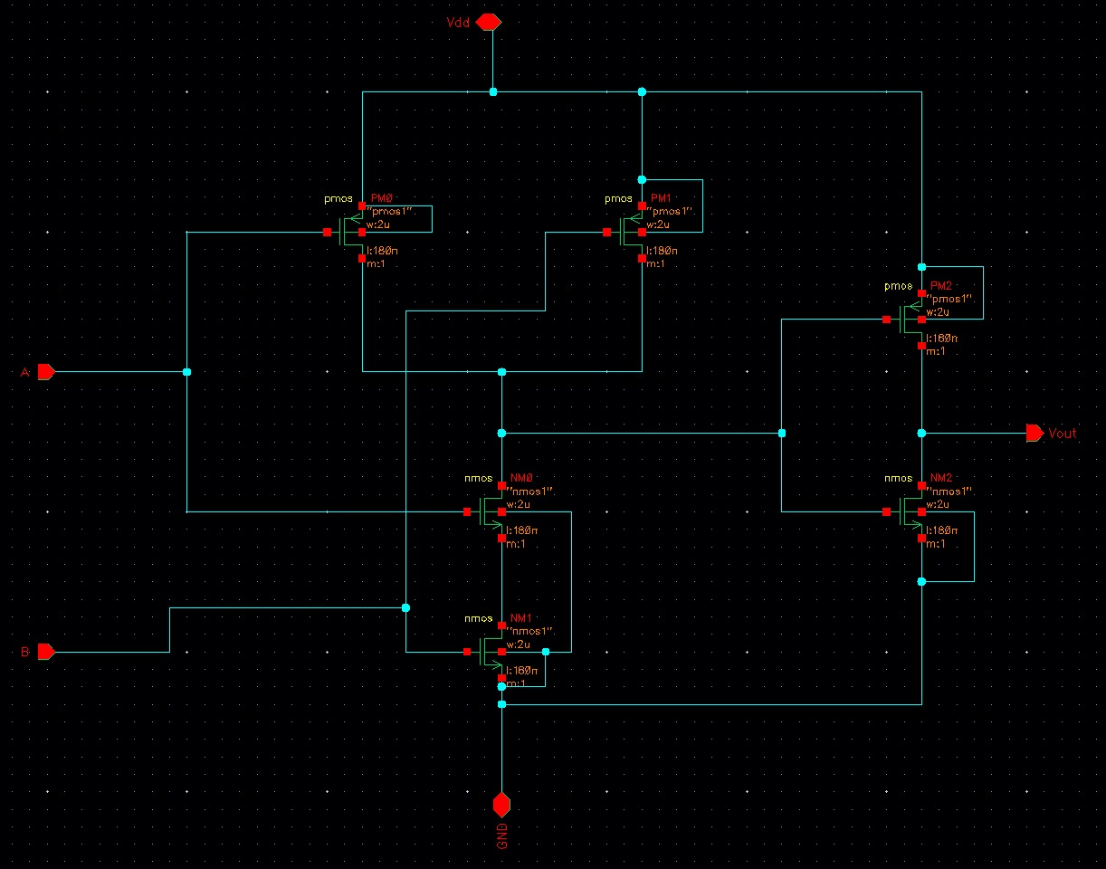

**Testbench**



**Waveform**

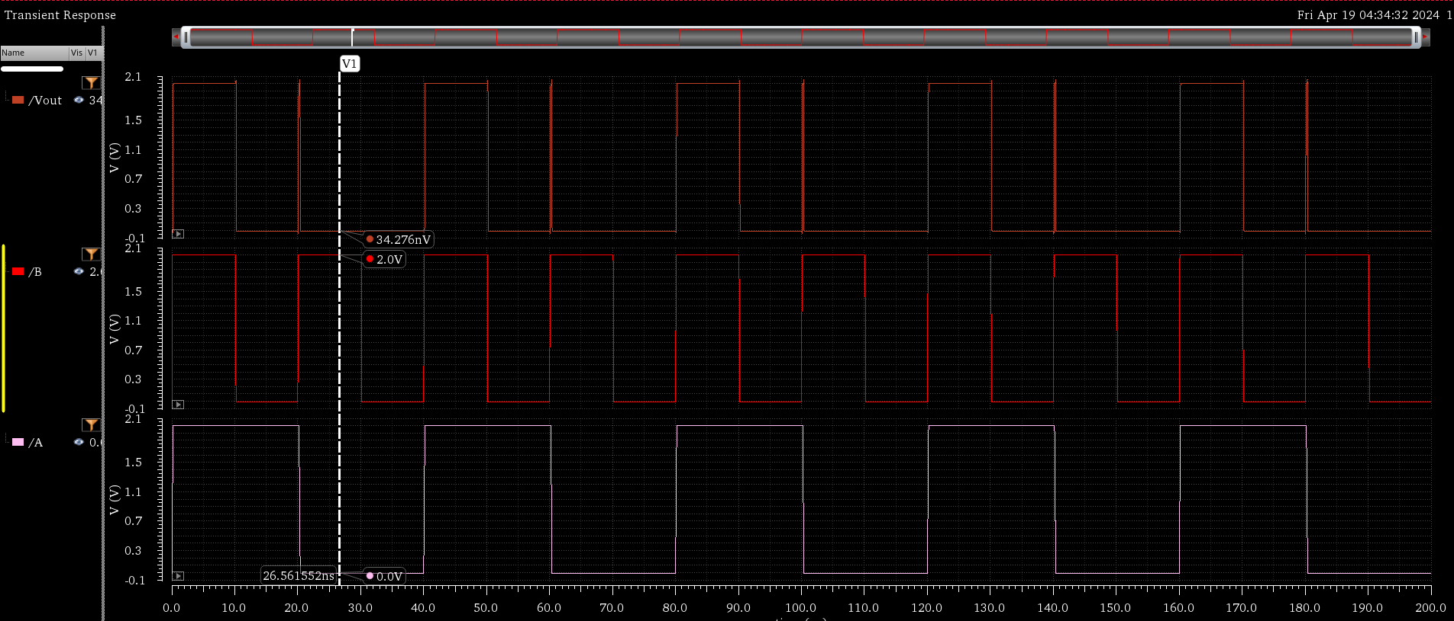

***OR***

**Schematic**

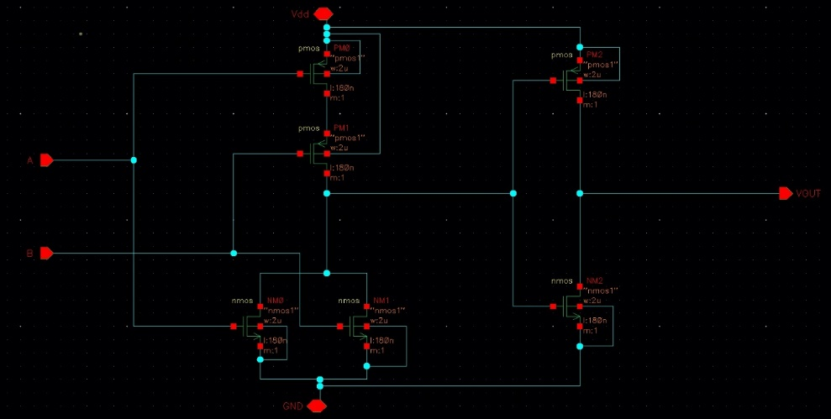

**Waveform**

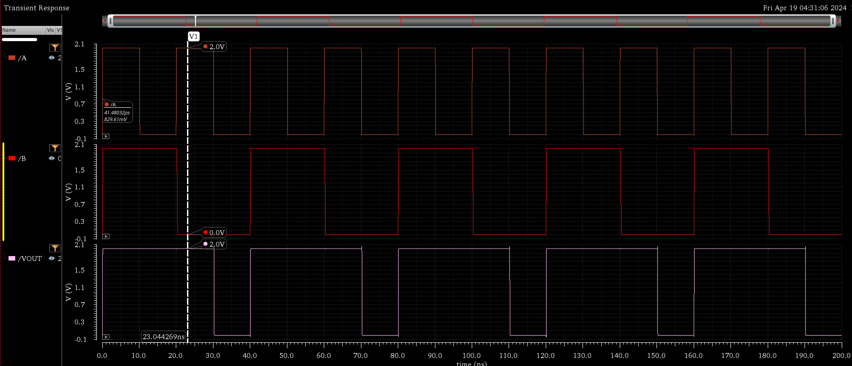

***XOR***

**Schematic**

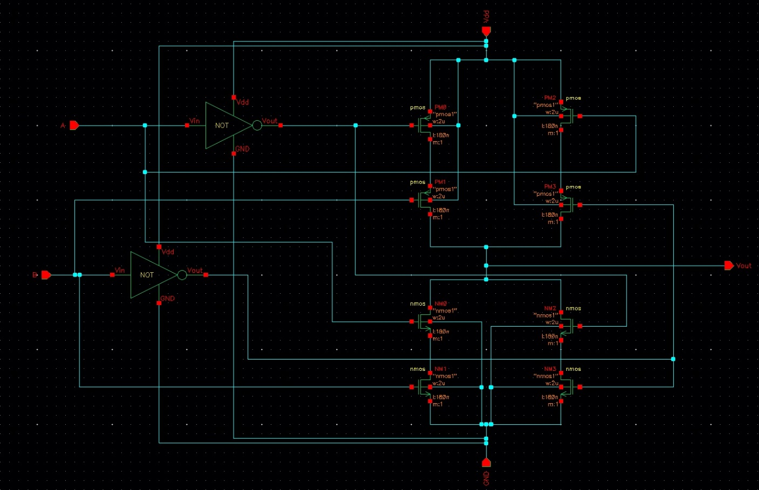

**Testbench**



**Waveform**

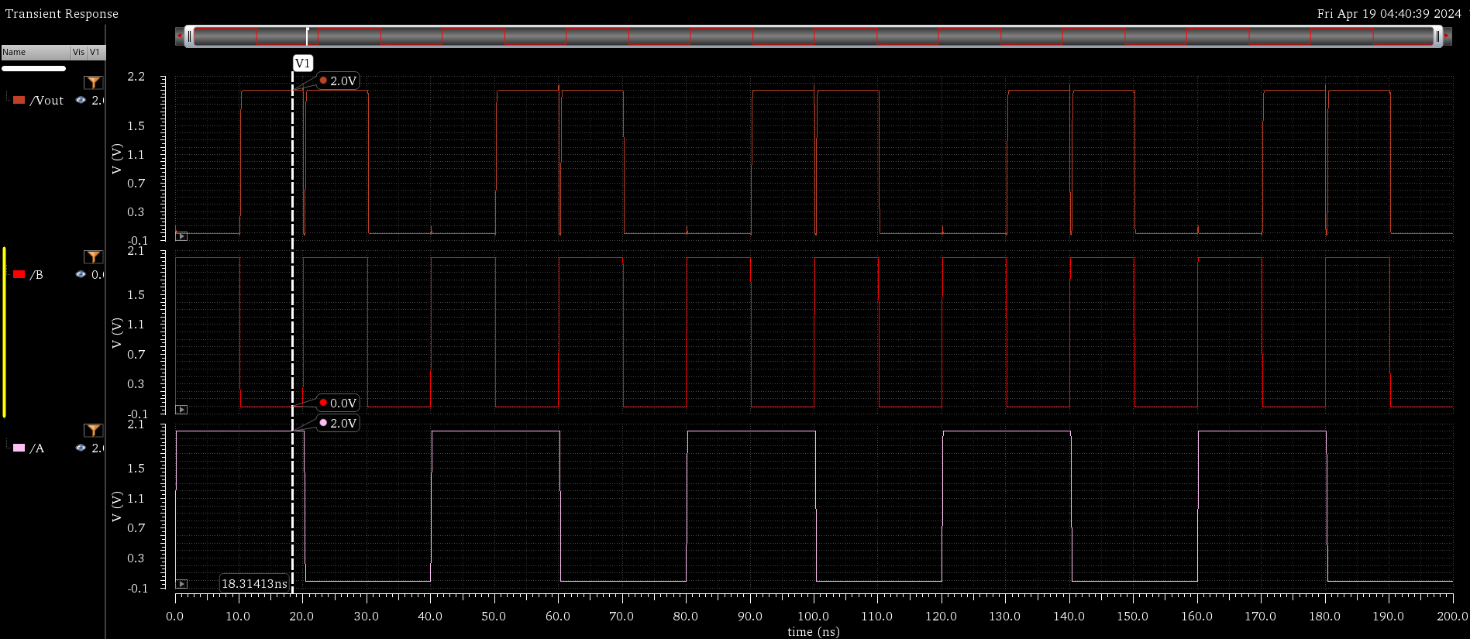

***INVERTER***

**Schematic**

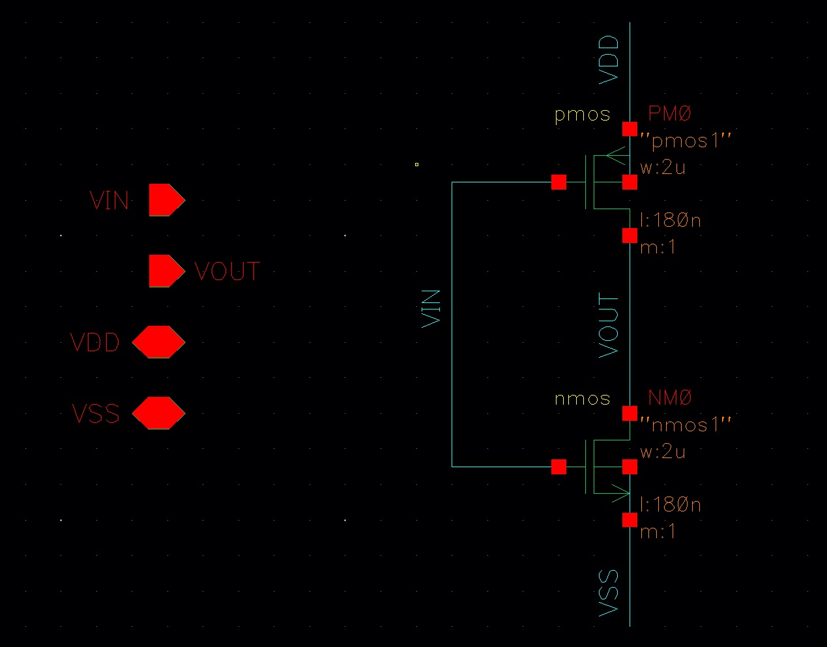

**Testbench**



**Waveform**



***FULL ADDER***

Carry refers to the extra bit generated when performing addition, particularly when adding numbers in binary representation. It indicates that the result exceeds the capacity of the given number of bits.

Overflow, on the other hand, occurs when the result of an arithmetic operation, such as addition or subtraction, exceeds the range that can be represented by the given number of bits. It's specifically related to the sign of the numbers involved in the operation.

Schematic

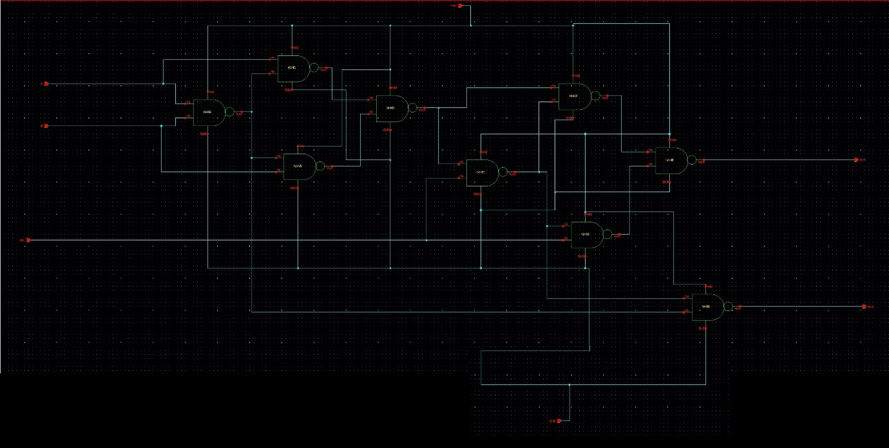

**Testbench**

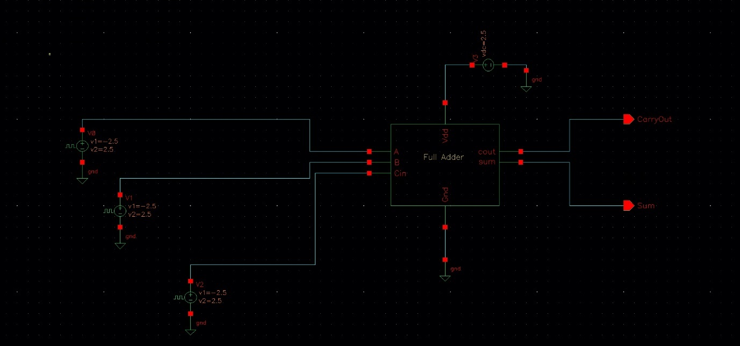

**Waveform**

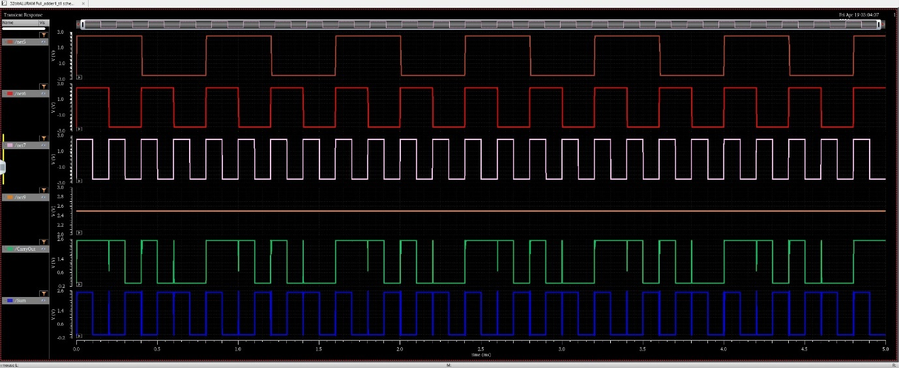

***4x1 MUX***

**Schematic**

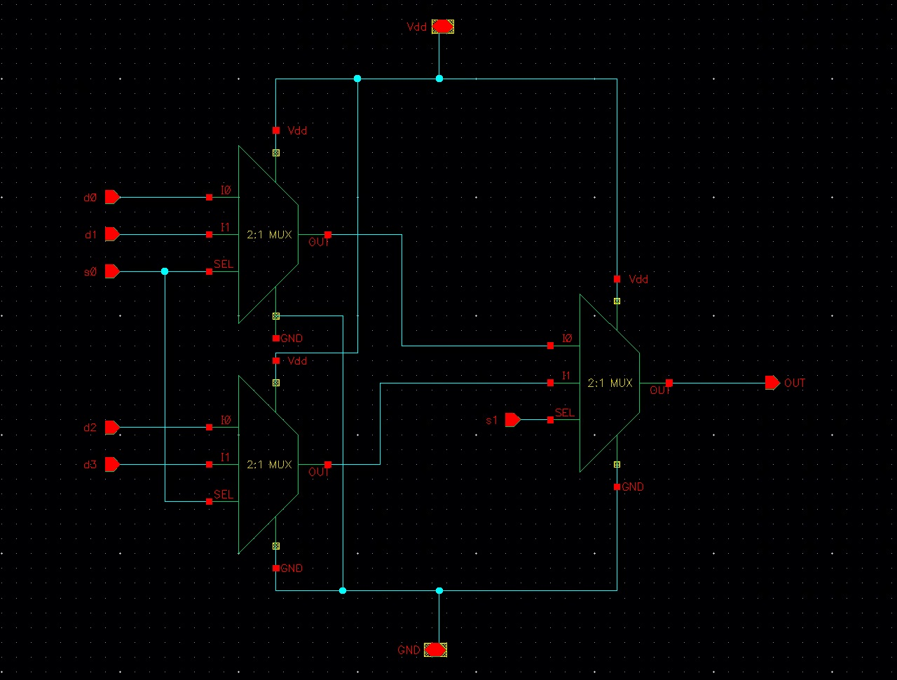

**Testbench**

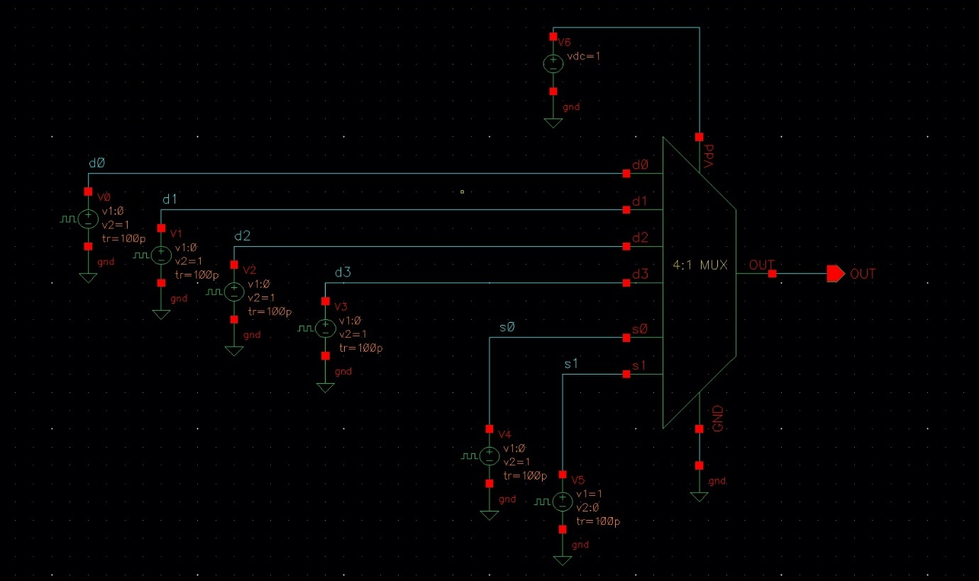

**Waveform**

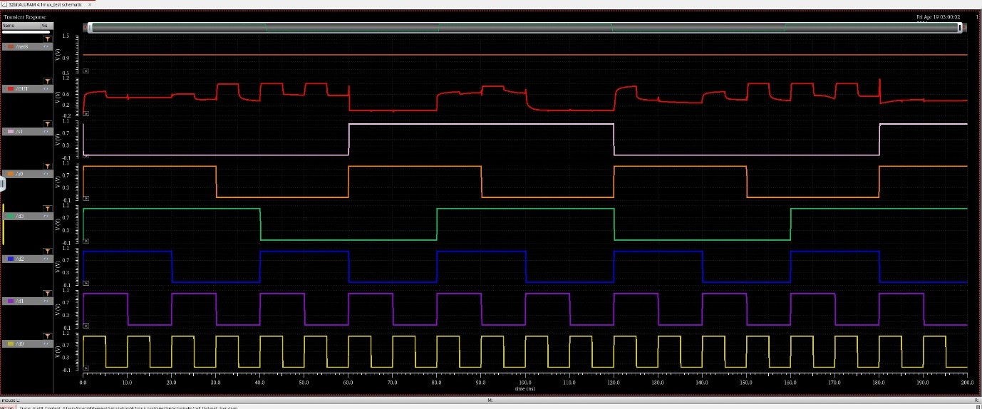

***2x1 MUX***

The two-way 1-bit MUX selects between two inputs based on a control signal. It's used to implement the negator and XOR gate. By transferring the select signal and its complement to the outside, it facilitates easier control of the MUX within the circuit design.

Schematic

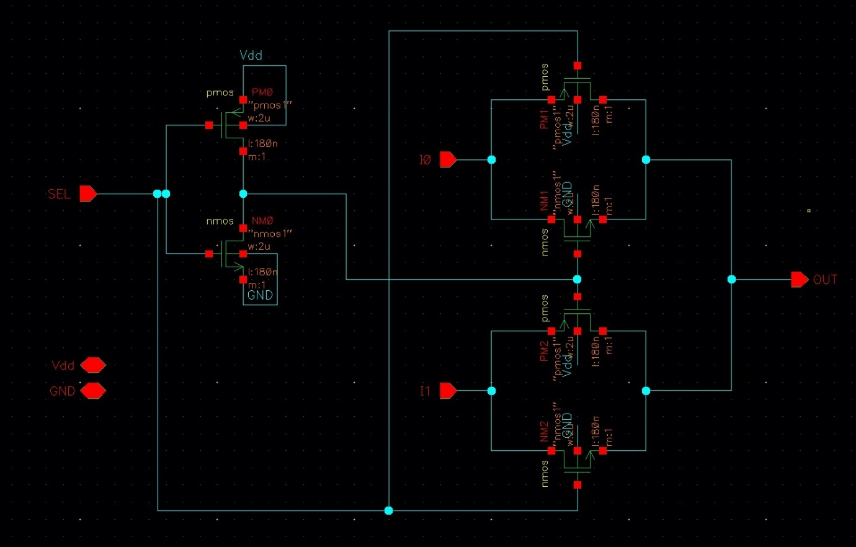

**Testbench**

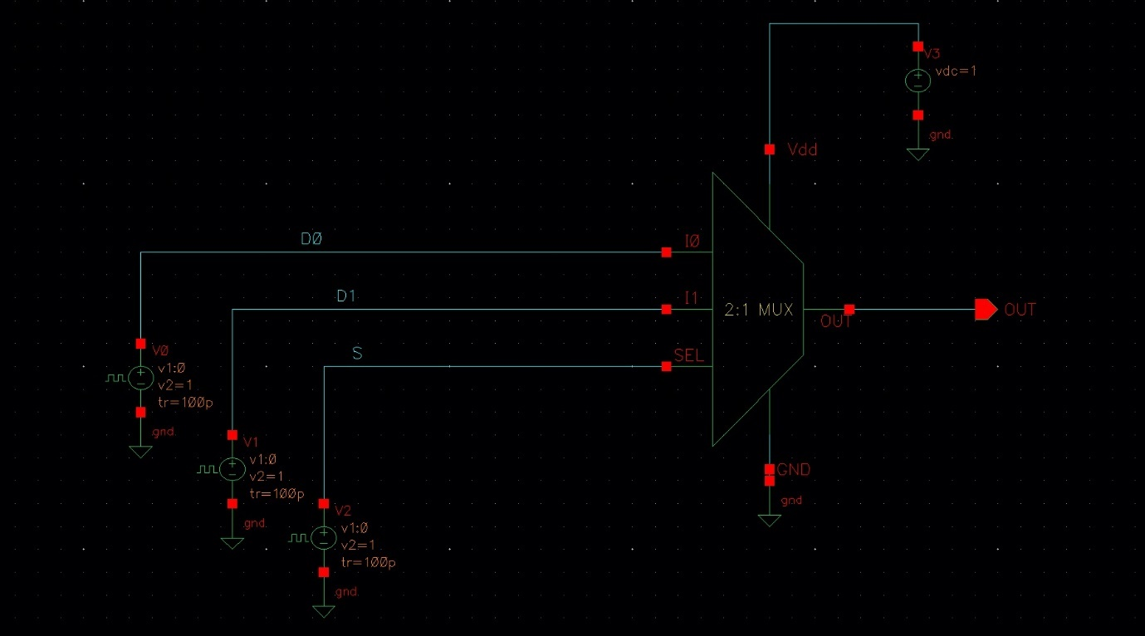

**Waveform**

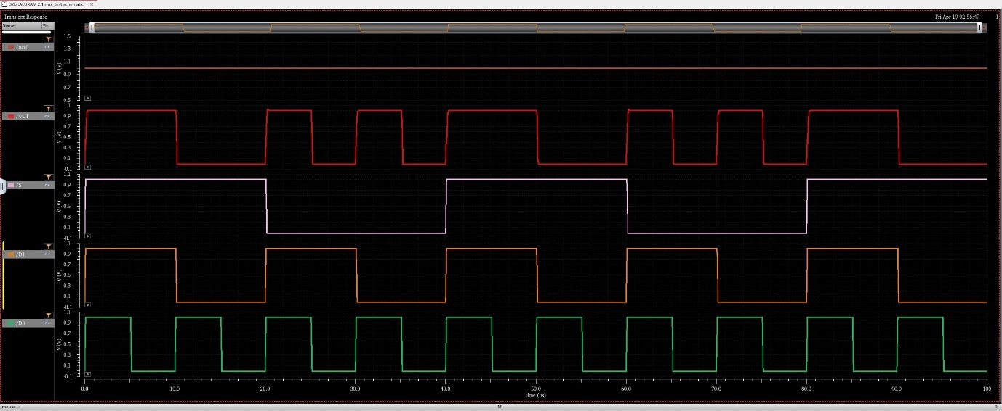

***NOT***

**Schematic**

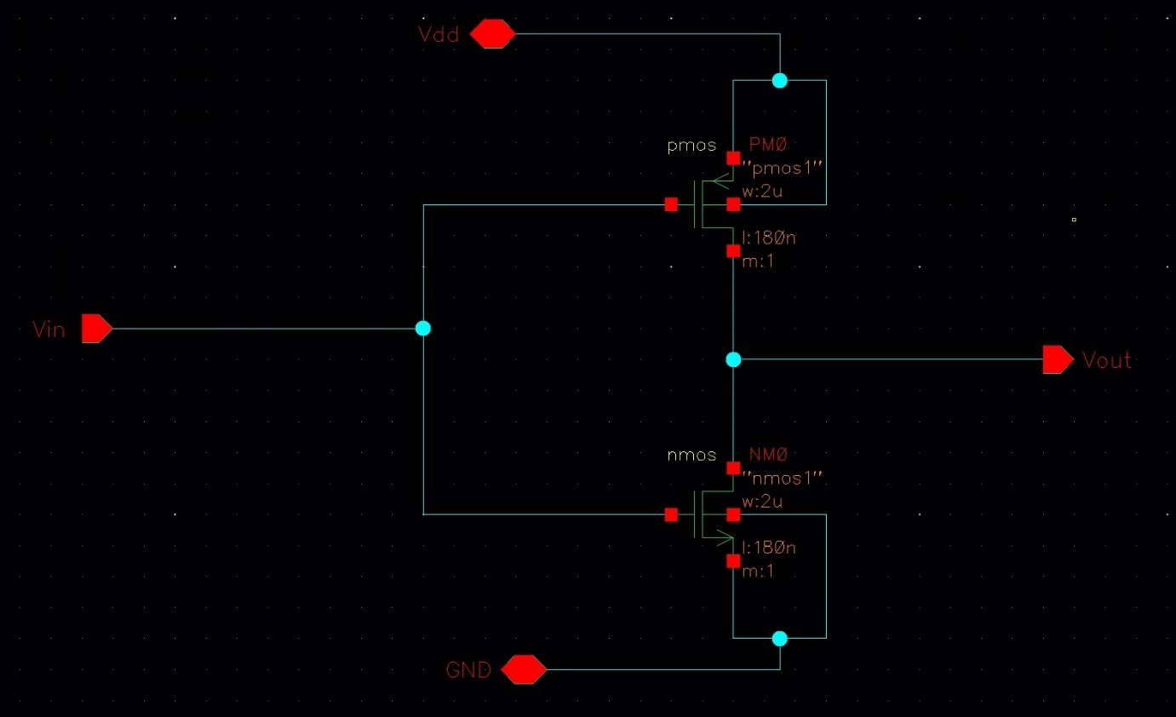

**Testbench**

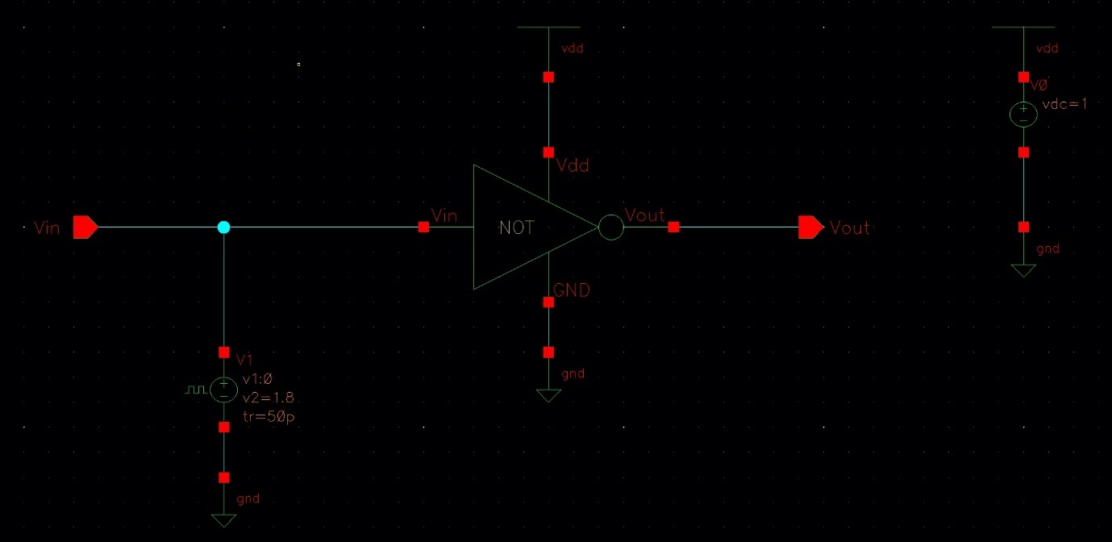

**Waveform**

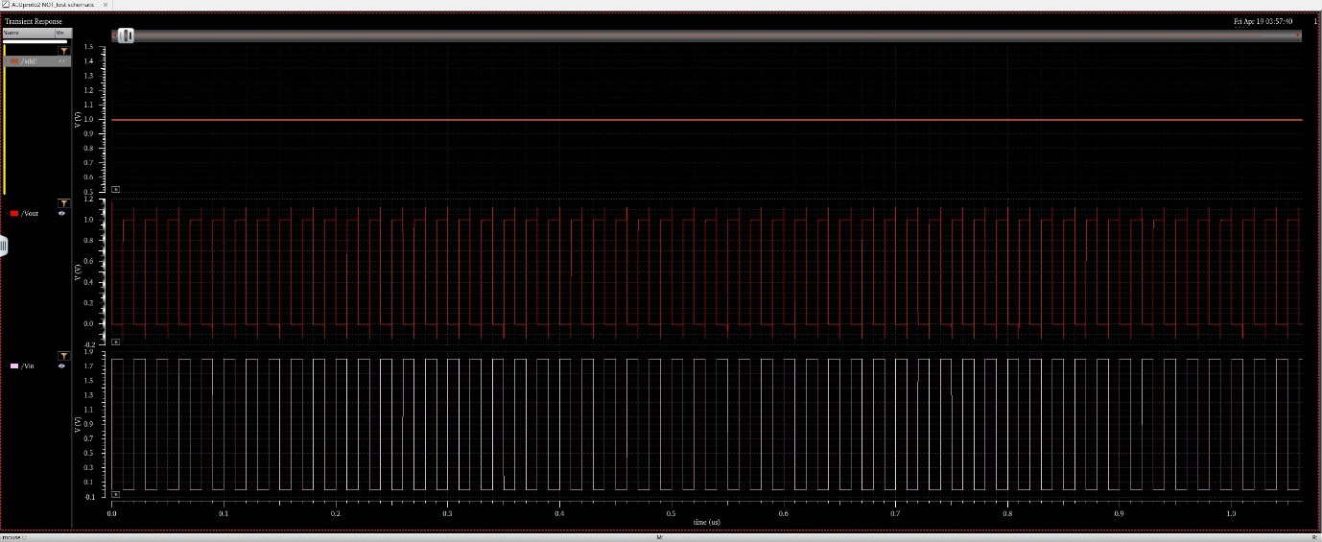

***NAND***

**Schematic**

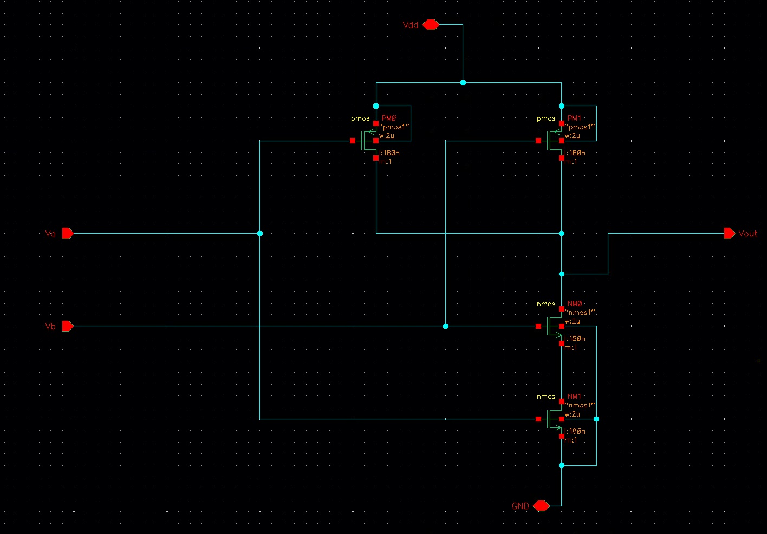

**Testbench**

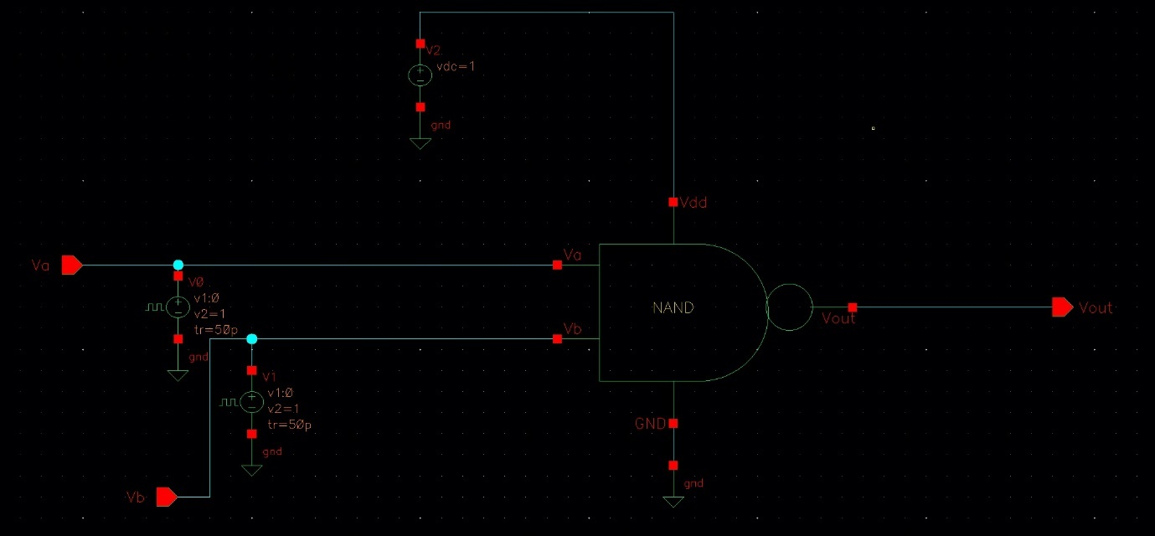

**Waveform**

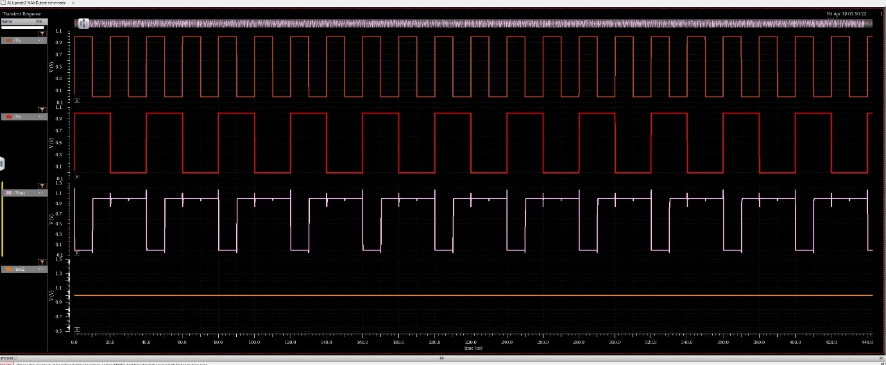

***1-BIT ALU***

**Schematic**

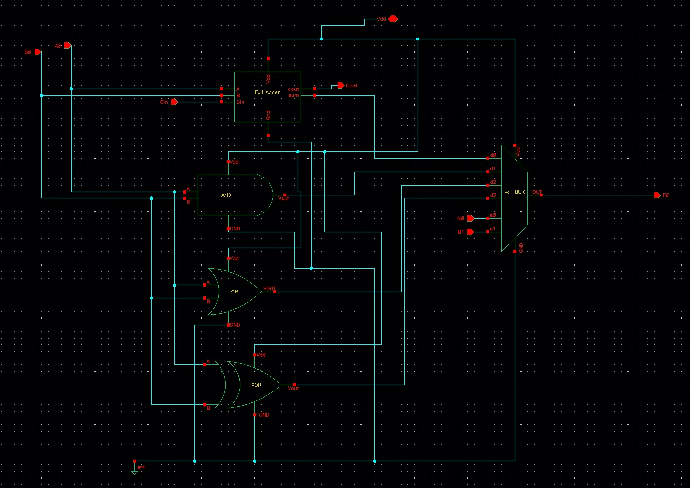

**Testbench**

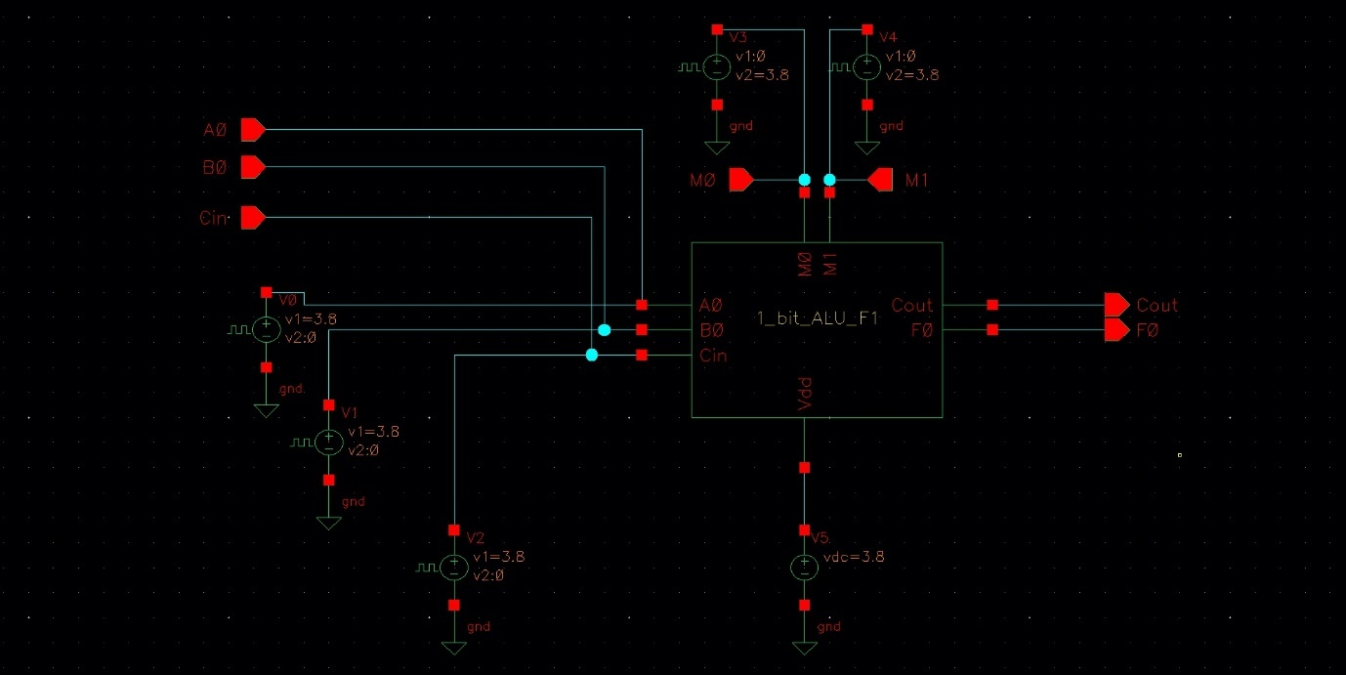

**Waveform**

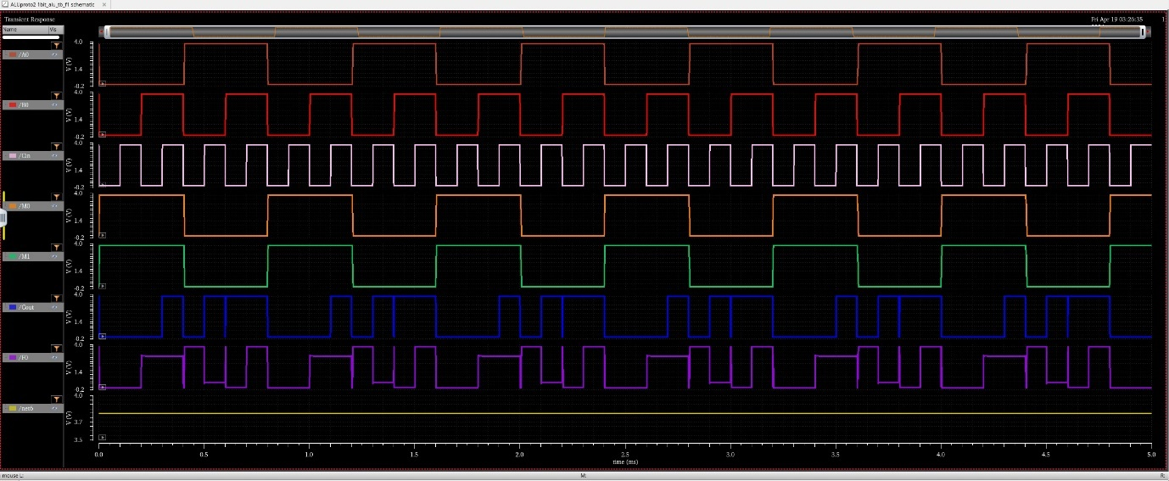

***32-BIT ALU***

**Schematic**

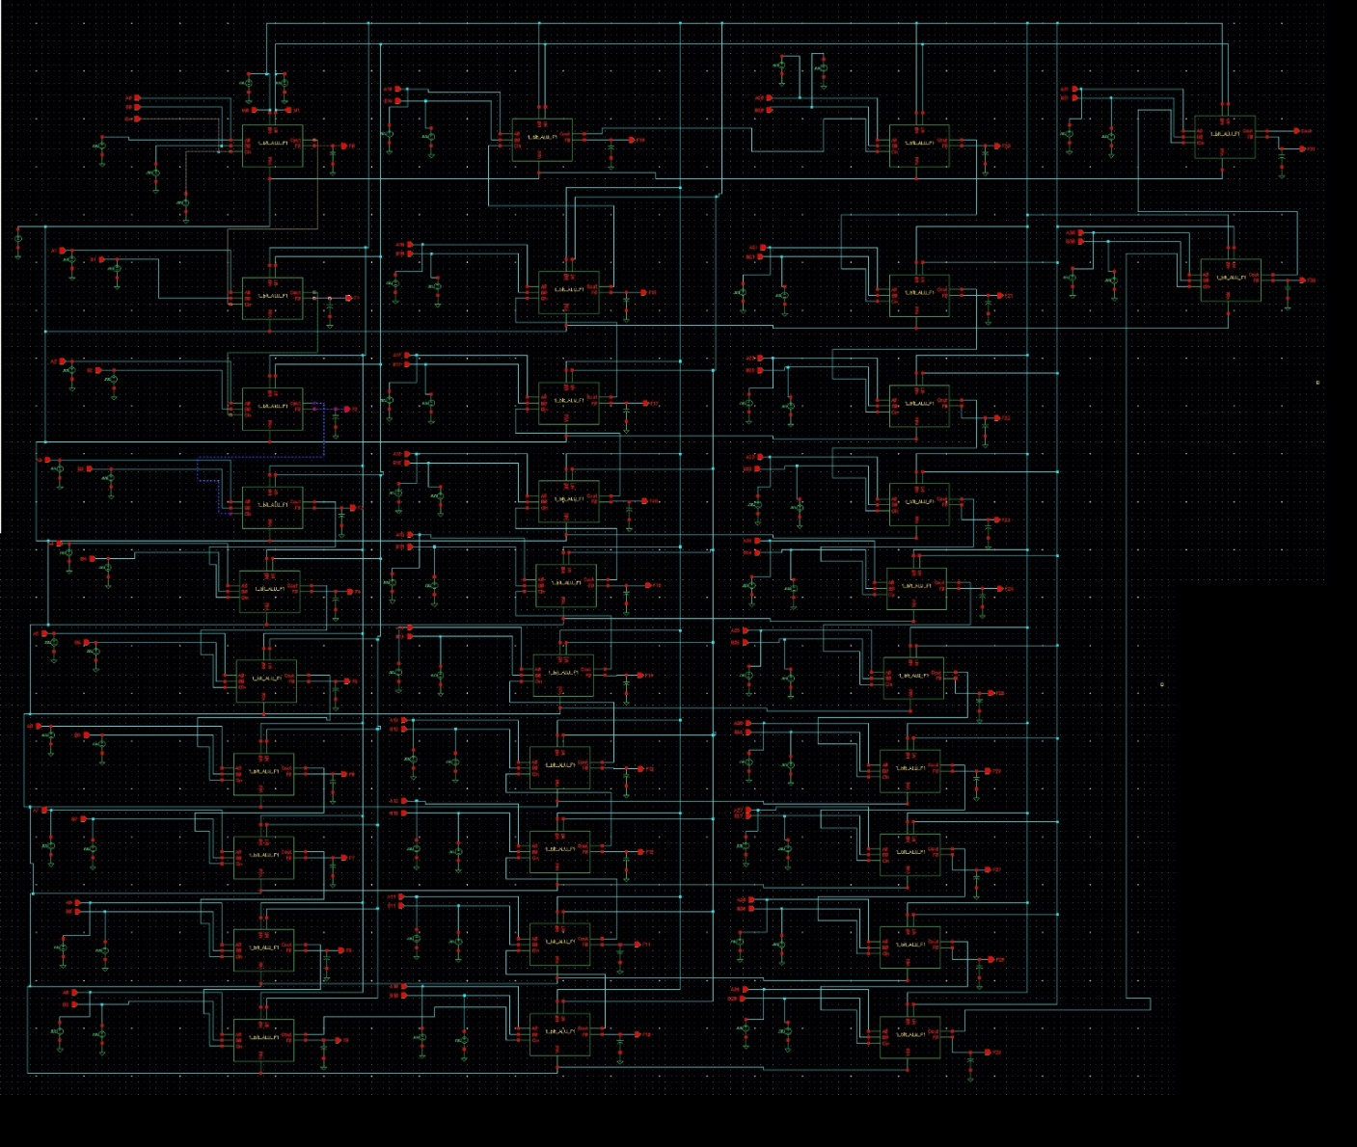

**Waveform**Input of A

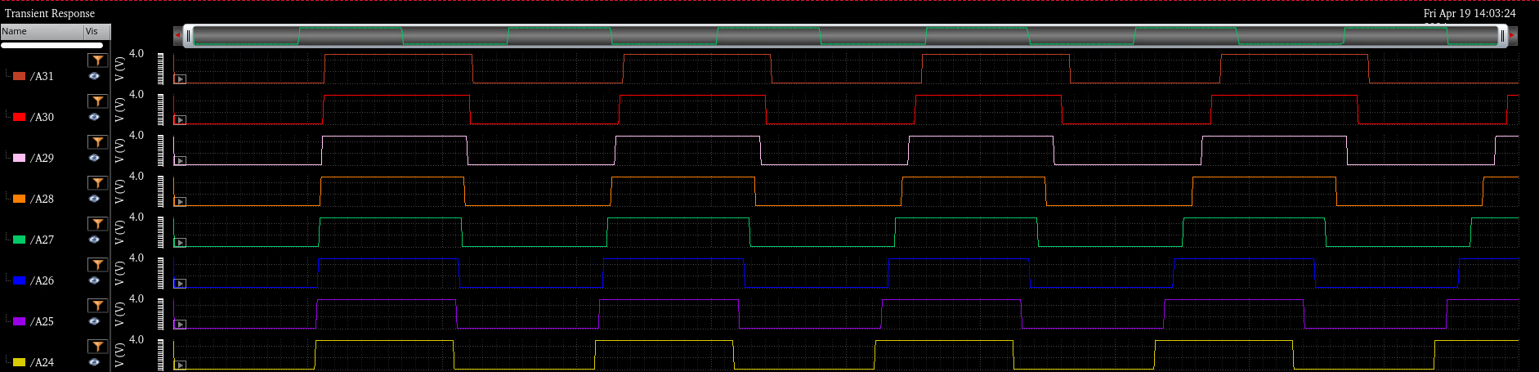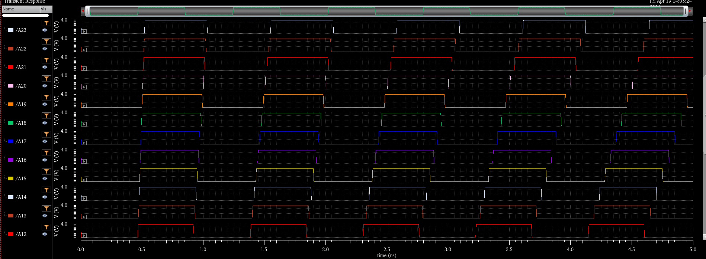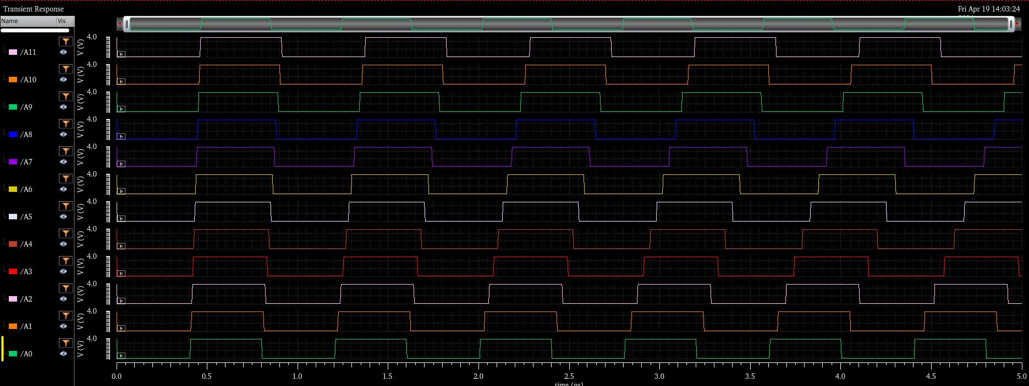

Input of B

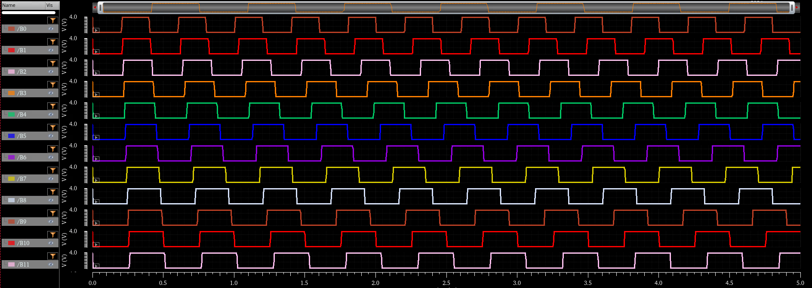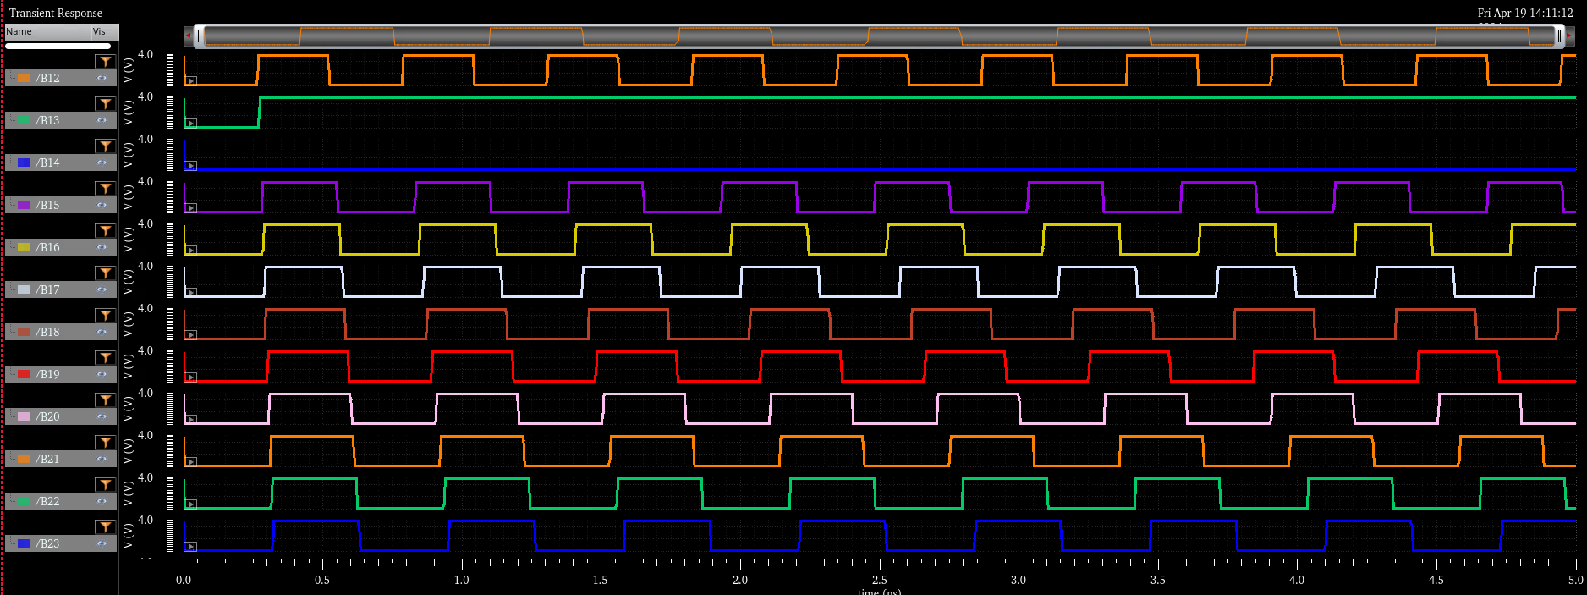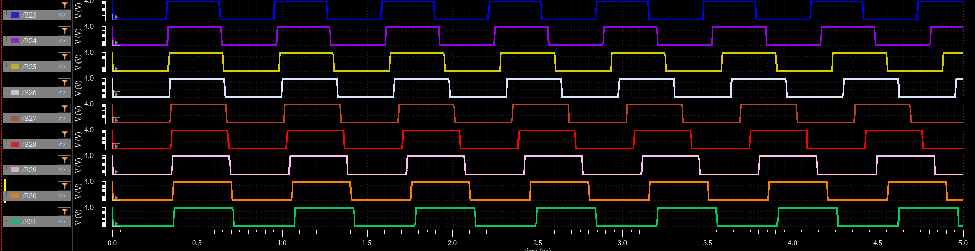

**Output ::**

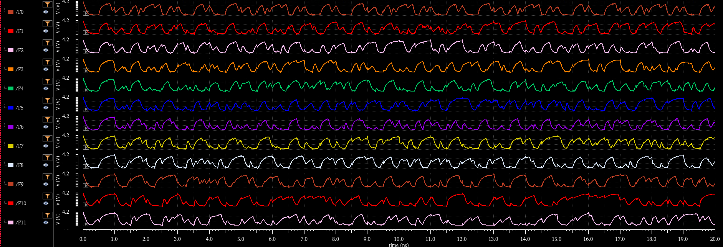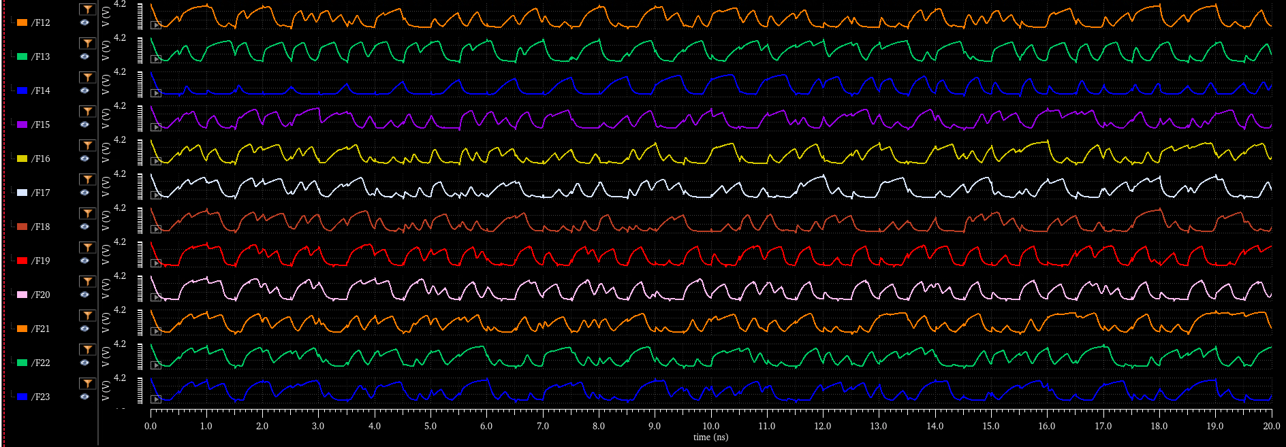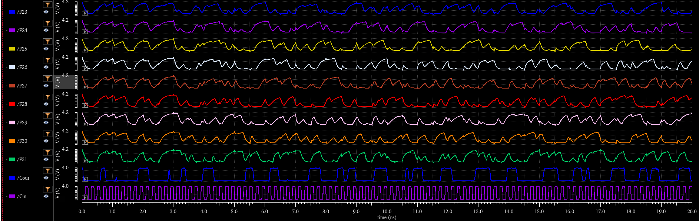

TABLE I: ADDERS POWER COMPARISON

|  |  |  |
| --- | --- | --- |
| Adder | Without BGFSB power(W) | With BGFSB power (w) |
| 10T Adder | 1.12e-6 | 6.77e-6 |
| 14T Adder | 3.535e-7 | 1.965e-6 |
| CPL Adder | 8.85e-7 | 7.3e-6 |
| Hybrid Adder | 5e-6 | 5.8e-6 |

TABLE I: ADDERS DELAY COMPARISON

|  |  |  |
| --- | --- | --- |
| Adder | Without BGFSB Delay(s) | With BGFSB Delay(s) |
| 10T Adder | 1.55e-10 | 1.09e-10 |
| 14T Adder | 5.818e-11 | 2.3e-12 |
| CPL Adder | 1.32e-10 | 1.02e-10 |
| Hybrid Adder | 6.5e-10 | 5.4e-10 |

**Delay:**

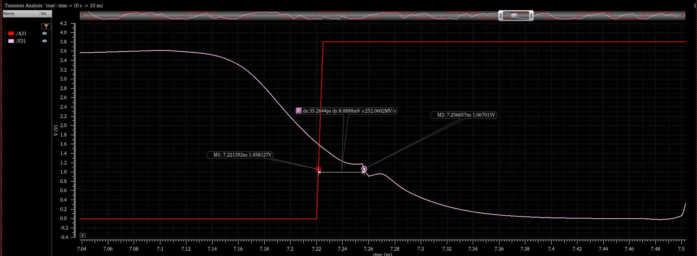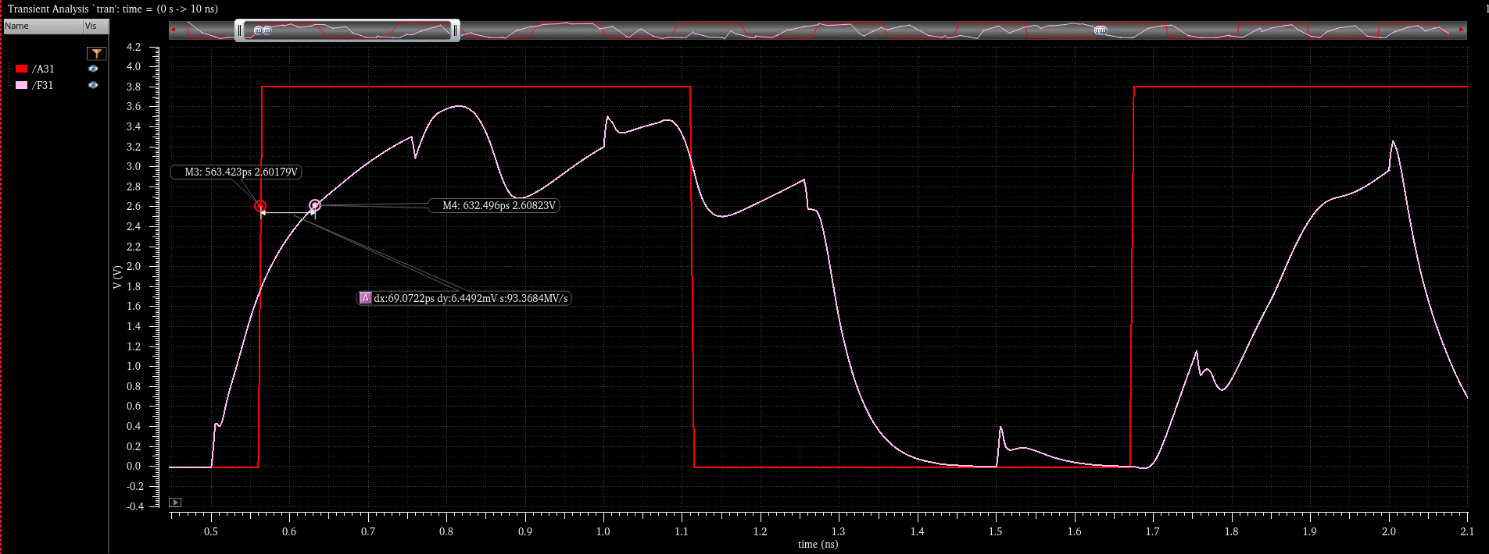

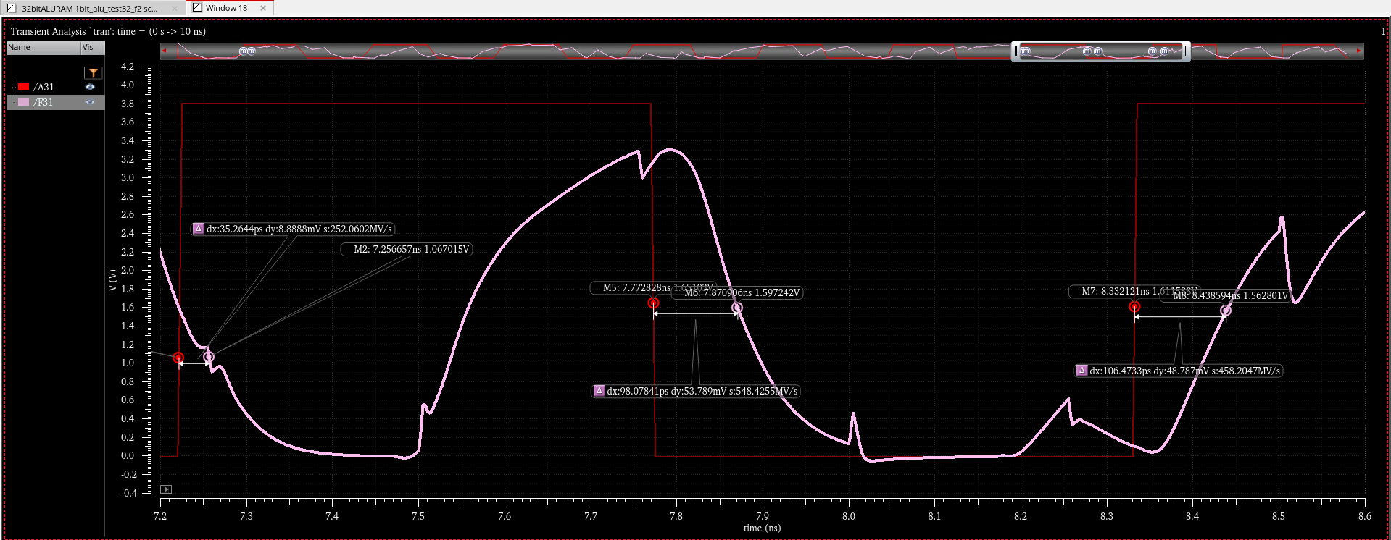

**The propagation delay: 63.08 ps**

**The power consumed::**

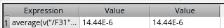  
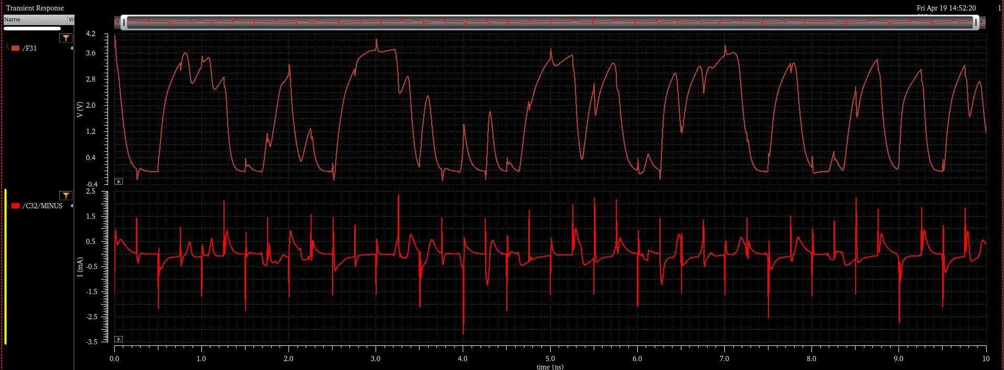  
the power consumed was 14.44 uw

TABLE IV: DELAY ESTIMATION OF ALU

|  |  |  |
| --- | --- | --- |
| ALU DESIGN | WITHOUT BGFSB DELAY(Sec) | WITH BGFSB DELAY(Sec) |
| 1 Bit ALU | 5.36e-12 | 2.35e-12 |
| 8 Bit ALU | 6.48e-12 | 2.46e-12 |
| 16 Bit ALU | 6.8e-12 | 3.2e-12 |
| 32 Bit ALU | 7.04e-12 | 4.2e-12 |

TABLE I: ADDERS POWER COMPARISON

|  |  |  |
| --- | --- | --- |
| ALU DESIGN | Without BGFSB Power(W) | With BGFSB Power (w) |
| 4 Bit ALU | 8.094e-10 | 2.45e-4 |
| 8 Bit ALU | 12.45e-10 | 4.4e-4 |
| 16 Bit ALU | 16.56e-10 | 6.5e-4 |
| 32 Bit ALU | 20e-10 | 8.06e-4 |

**#Transistor Sizing:**

1. **Inverter Power Graph:**



**• Results:**

So, from the graph we can see that:

For 380uW – Pmos :7.5u

Nmos: 3u

For 220uW – Pmos:5u

Nmos: 2u

1. **AND Gate:**



• Results:

So, from the graph we can see that:

For 39pW – Pmos :7.5u

Nmos: 3u

For 22pW – Pmos:5u

Nmos:2u

**Conclusion:**

The design and implementation of the 32-bit Arithmetic Logic Unit (ALU) have been successfully achieved with a systematic and methodical approach. The development process began with the creation of a 1-bit ALU, which was then scaled and replicated to form the 32-bit ALU. This modular approach not only facilitated the design process but also ensured consistency and compatibility across the ALU's architecture.

Through careful research and analysis, a suitable implementation methodology was selected, taking into account key performance parameters such as area, propagation delay, and power consumption. This informed decision-making process enabled the optimization of transistor sizes and configurations to achieve desired performance metrics.

Simulation played a crucial role in the design validation phase, providing insights into the ALU's functionality and performance characteristics. By conducting thorough simulations, the ALU's operational efficiency, speed, and reliability were verified, ensuring that it meets the required specifications and performance targets.

In conclusion, the 32-bit ALU design represents a robust and efficient computational unit capable of performing a wide range of arithmetic and logical operations. Its modular design, optimized transistor configurations, and validated performance metrics demonstrate its suitability for integration into complex digital systems and applications.

**Detailed Report Preparation Contributions**

1. **Jeet Patel:**
   * **Introduction and Objectives:** Jeet wrote the introduction of the report, which outlines the project scope, objectives, and the importance of the ALU design in modern computing. This section sets the stage for the detailed descriptions that follow.
   * **Technology Selection and Strategy:** He also prepared the section on technology selection, explaining why the 180 nm technology node and the gpdk180 library were chosen for the project. This includes a discussion on the benefits of CMOS technology for low power consumption.
2. **Sriram Ganapati Bhagwat:**
   * **Technology Selection Rationale:** Sriram detailed the rationale behind choosing specific technologies and methodologies, including insights into how these decisions align with the project’s goals of minimizing power and delay.
   * **Layout Optimization:** He documented the layout optimization processes and the specific challenges addressed during scaling from the 1-bit to the 32-bit ALU design, emphasizing the technical solutions employed to overcome these challenges.
3. **Yogeshwaran Eswaran:**
   * **Design Methodology:** Yogeshwaran was responsible for the section detailing the design methodology, including the creation of custom symbols and the initial simulation tests. This part of the report provides a comprehensive look at the foundational work that went into building the ALU.
   * **Simulation and Performance Optimization:** He also wrote about the extensive simulations carried out to verify the ALU’s functionality and performance, discussing the optimization strategies used to enhance the circuit’s efficiency.
4. **Aryan Adittya Mahadi:**
   * **Symbol Creation and Initial Tests:** Aryan documented the symbol creation process and the initial tests conducted to ensure the symbols functioned as intended. This section includes descriptions of the logic gates and other components used in the ALU.
   * **Final Testing and Technical Adjustments:** He detailed the final testing procedures and the adjustments made to meet the specified technical requirements, explaining how the final design was validated to meet all performance targets.
5. **Collaborative Efforts:**
   * **Conclusion and Future Work:** All team members contributed to the conclusion, summarizing the project's successes and areas for future improvement. This section reflects on the project's impact and potential applications of the 32-bit ALU in real-world scenarios.
   * **Appendices and Technical Specifications:** The team collaboratively compiled appendices, which include detailed schematics, waveforms, and other technical specifications that provide deeper insight into the ALU’s design and performance.